TC07

**Test Scenario:** ESS User Should not be able to edit restricted details under personal details

**Test Case Title:** Verify ESS User should not be able to edit restricted details such as Employee ID

**Test Case Steps:**

1) Launch bowser

2) Login to OrangeHRM web portal

3) Click on My Info

4) Click on Personal detail

5) Try to edit Employee id detail

6) Click on save button.

**Let’s take screen of default Employee id first :**

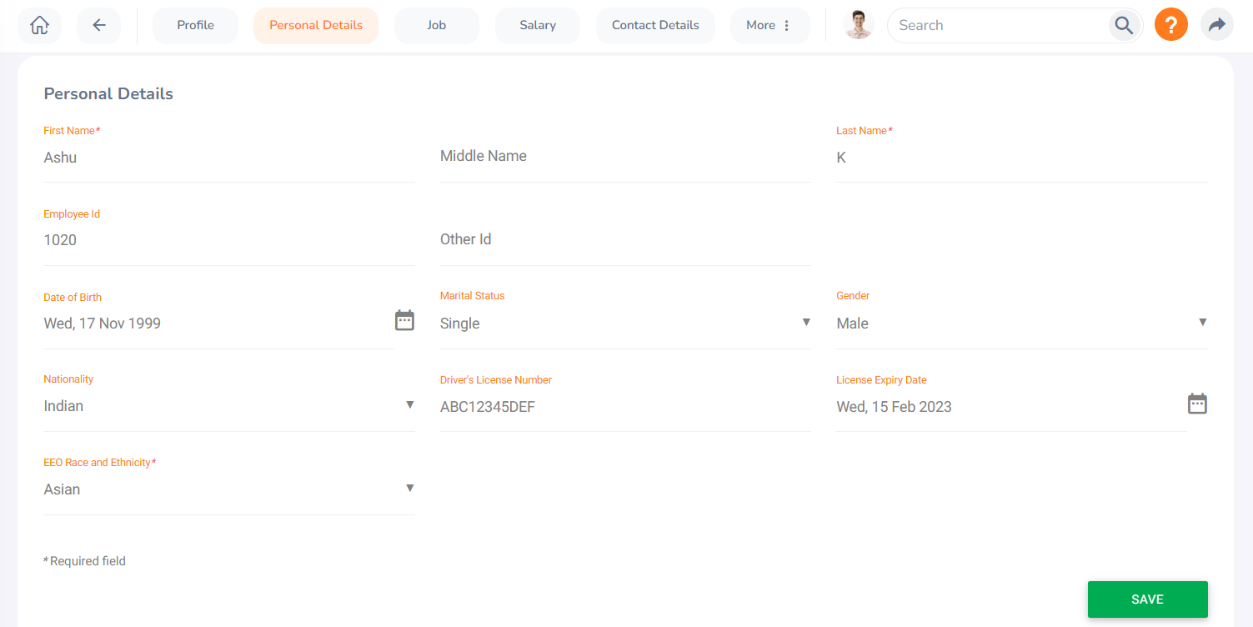

**Now let’s try to change Employee ID :**

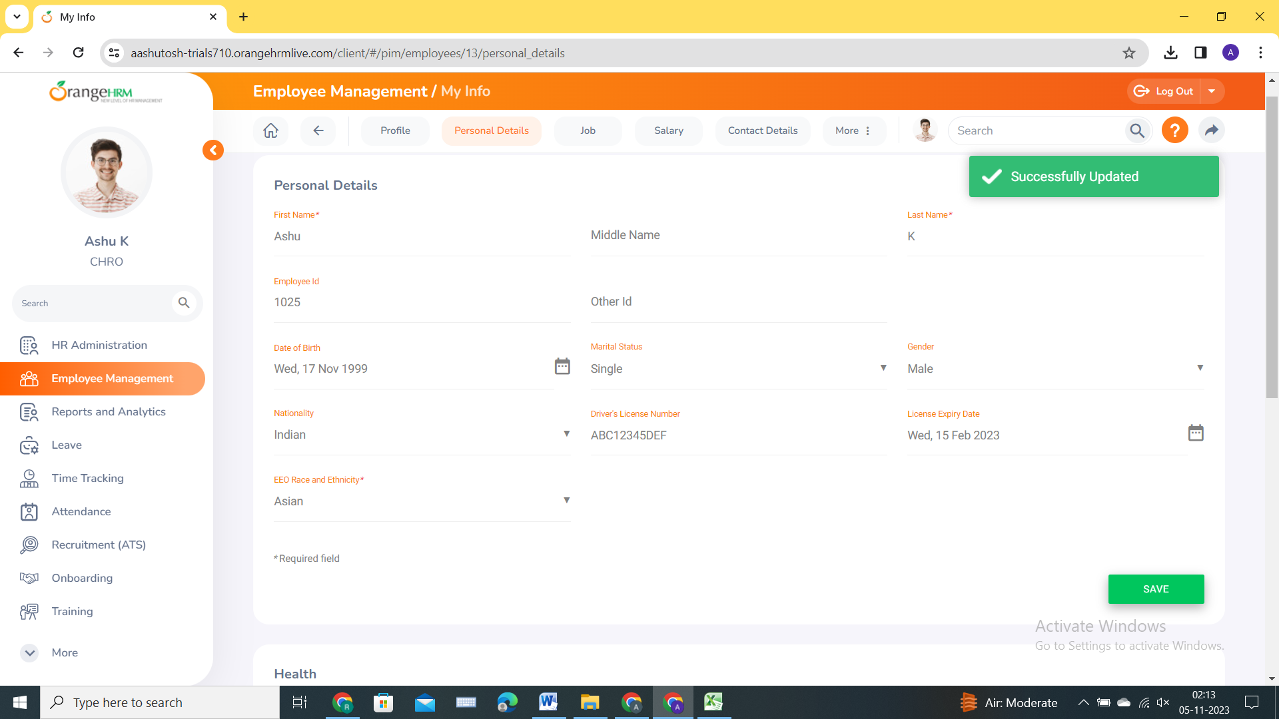

**Here we can see that we are able to change Employee ID without any restrictions. That should not be the case. So let’s raise defect for this so that we can track this issue and get it fixed. :**